\
This worksheet is courtesy of BeechTreeHandmade.com

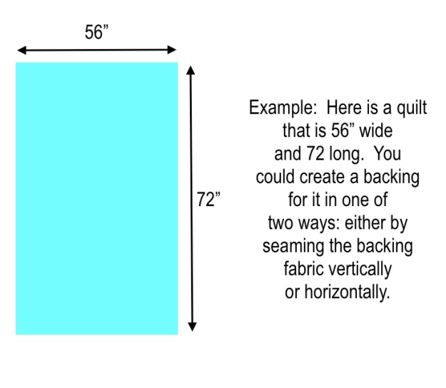
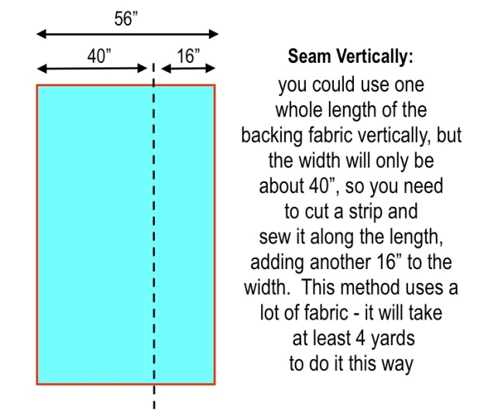
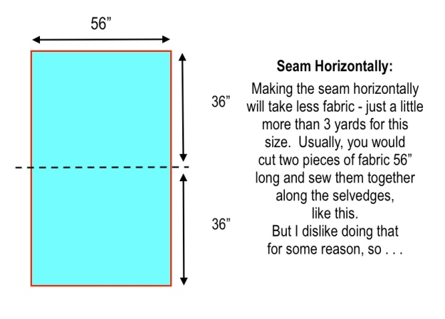
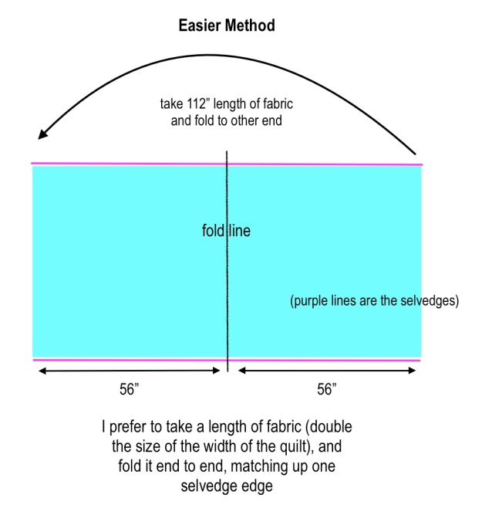
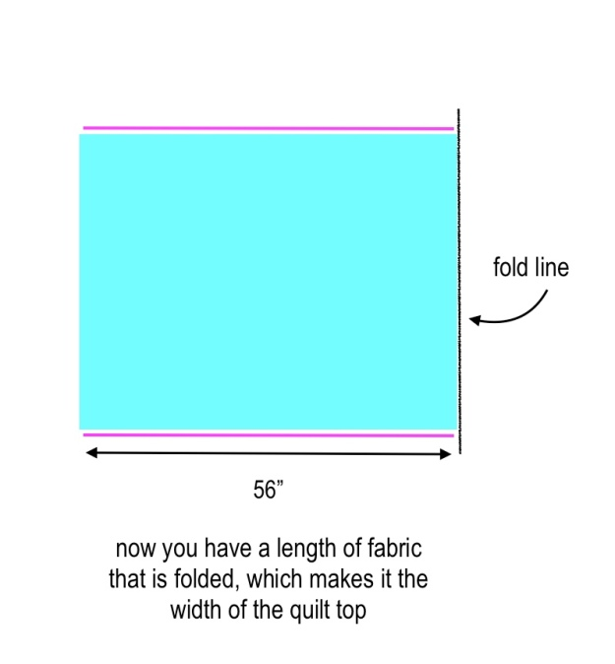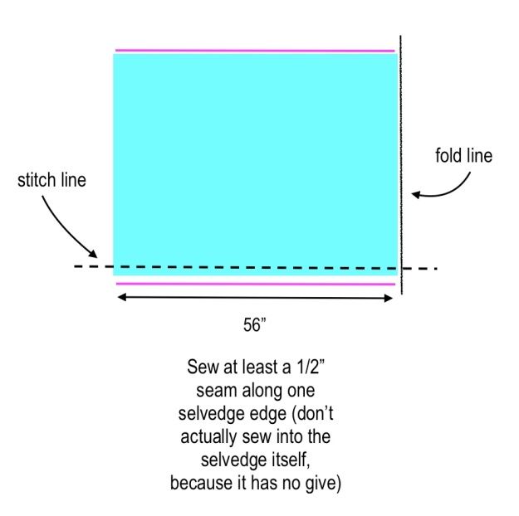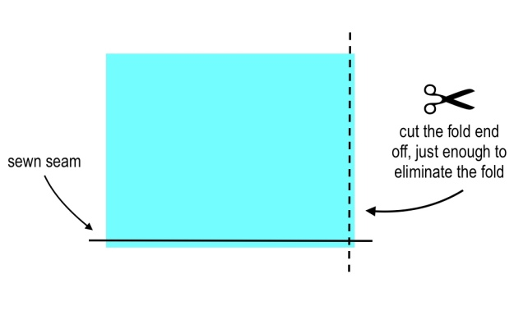

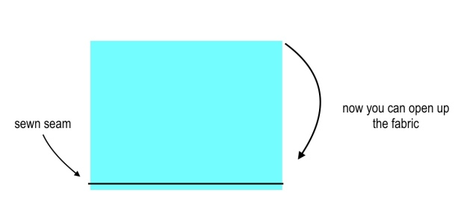

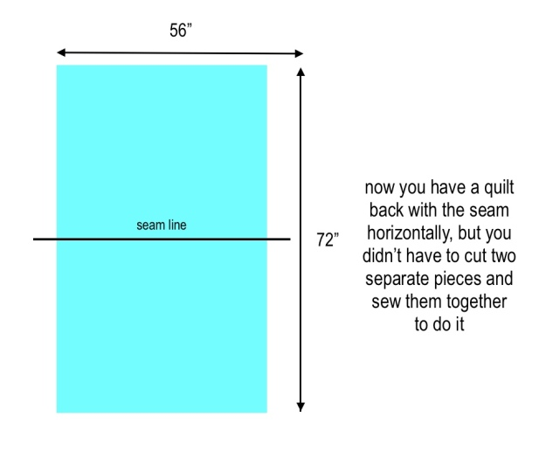
Now just trim the length to the size you want.
Tips:
● Cut the selvedges off before you press the seam open – they are tighter and have less give than the fabric itself and can cause a pucker sometimes. Make a big enough seam so that you can do this. So make your sewing line ½” away from the selvedge. Press the seam open so it lays flat.
● Use a walking foot if you can to sew the seam – it will move the fabric along better, so that it is even.

